End of Life Planning
From Your Endowment Fund Board
Christ Church Parish (EPISCOPAL) Middlesex
P.O. Box 476, Saluda, VA
http://christchurchmiddlesex.thediocese.net/default.asp
CCPARISH@VERIZON.NET

CAUTIONARY NOTE

The Endowment Fund Board of Christ Church Parish (Episcopal), Middlesex offers this document/planning tool as a guideline for end of life planning. It does NOT replace any documents created for you by your personal advisors who may be lawyers, investment counselors, estate planners, family members or the like.

It should be viewed only as a part of your overall plans and a way to take much of the burden off your next of kin.

This is a living, breathing document that should be reviewed periodically as you would any others such as your will. Please note that any time there are any changes because of death, divorce, major financial or any other major events in your life, you should review this and all other documents to determine if you should visit your advisors.

You may print this document and fill it in by hand
or you can go to the website, http://christchurchmiddlesex.thediocese.net/default.asp, find the document “End of Life Planning”, fill it in online, save and print.

Now that you have done your homework, make an appointment with your Clergy to make your wishes for the church known and placed on file at the Christ Church Parish office!

COMPLETION INSTRUCTIONS

If you are doing this document/brochure online, you will probably have to make some line adjustments by hitting the backspace key before you print because typing “Pushes” the text that follows. Avoid using the tab key and use the space bar or arrow keys to navigate the document.

Setting the Stage for your Planning:

Where to Begin?

There are two important areas each of should address: the secular and the sacred. By this we mean you will need to review both your financial and your spiritual arenas of life if you are to do the planning job completely.

Secular:
Whatever your financial position in life, whether of limited means or of great wealth, your death will mean paperwork for someone. Your planning efforts can help to eliminate some of that stress and paperwork. Frustration with paperwork is not something that your loved ones need to deal with on top of the emotional challenges of your death.

If you were to die tomorrow, would others know where to look for your important documents? Does your family know about your bank accounts, insurance policies, pensions, and investments? Do you have a current will or trust and if so, where are they kept?
Begin by creating a file with these important documents and pieces of information and let your loved one(s) know where this can be found.
Meet with your accountant, financial planner or investment broker to ensure you have designated beneficiaries according to your wishes – now! What you indicated in years past may no longer be valid or in keeping with your current desires.

Meet with your lawyer to ensure that your will is current and reflects your true desires. Remember: if you don’t address these concerns, the Government will, and you might not be happy with their decisions.

You need also to have a current Power of Attorney and an Advance Medical Directive so that your loved one(s) will know what you desire concerning your end-of-life care and be authorized to undertake actions and/or make decisions on your behalf, should you be unable to do so.

Remember, conversations with loved ones concerning these important matters are often soon forgotten, or only selectively remembered – documents speak clearly. Action on your part now might well prevent a family disagreement in the future.

Sacred:
How do you envision ending this earthly pilgrimage? Clergy should always be notified in cases of serious illness, especially in life-threatening situations. Let your family, your doctors, your hospital and other caregivers know that your clergy should be called.

Since you are a church member, you have hopefully executed and filed some document outlining your desires concerning funeral rites and burial with your church office. This document will do just that and ensure both that your desires are known and honored and that loved ones know what your desires really are.

Additional Thoughts:
Do not assume “everyone knows what I want”, because they often don’t or have forgotten. Do your loved ones a great favor by planning for this moment in your life. You may wish to meet with your local funeral director to pre-plan the key aspects of your service that they will be responsible for. Remember, do not assume that others will honor your desires or chose to remember your church or favorite charities the way you want, especially when balanced against their own desires or present needs. As the old saying puts it, “If you want something done right, do it yourself & do it in writing.”

End of Life Planning Check List:
The document suggestions listed below will provide you with some guidance as you start planning for this eventuality.

Document* Date /Complete/Notes
(Add notes if needed on the last page)

Advance Medical Directive
Power of Attorney
Medical Power of Attorney
Will/Trust Document
Codicil(s) to Will (If any)
Funeral Pre-plan (With funeral director)
Pre-Plan Burial Instructions
(With your Church)
House Docs. (Deeds, titles etc.)
Insurance Document
Pension Documents
Social Security Documents
Investment Documents
Banking Information
Passwords & Pins

*Your lawyers or other advisors may recommend that you add to or delete some of the above items.

Christ Church Parish
Pre-Plan Burial Instructions for:
Last Name First Middle (Maiden)
Date of Birth
Place of Birth
Present street address
(city/town)
(state)
(zip)
(telephone)

Contact Person:
(Person most likely to contact the church and funeral director)
Name Relationship Phone

Name Relationship Phone
Funeral Home:
- Do you have, or will you soon be making, a pre-arrangement agreement with the funeral director?
Yes ☐ No ☐
- Do you desire a Viewing/Calling Hours at the Funeral Home? If yes, for how long?
Yes ☐ No ☐ Hours
- I desire an open casket at the funeral home.
Yes ☐ No ☐ NA ☐
- I want an open casket viewing in the Parish Hall.
Yes ☐ No ☐ NA ☐
Special arrangements desired

Means of Conveyance of Earthly Remains:
- I wish to be buried in the ground (traditional burial).
Yes ☐ No ☐
- Type of Casket:
Wood ☐ Metal ☐ Cloth ☐ NA ☐
- Flower/spray for the casket
Yes ☐ No ☐ NA ☐
Note: The casket is covered by a cloth pall during the funeral service in the Episcopal church.
2. I wish to be cremated with the ashes buried in the ground
Name of Cemetery
Location
Lot #

3. I wish to be cremated with my ashes scattered.
Yes ☐ No ☐ Leave w/family ☐
- Explain the means of scattering, location &/or
Family Member
- It is appropriate and encouraged that cremains be present at the service and covered with the pall.
Yes ☐ No ☐
- I wish to donate all or part of my body for scientific or medical purposes & have made those arrangements & remains if any cremated.
Yes ☐ No ☐

Funeral Service Location:

It is my desire that my Funeral Service be held:
- In Church Yes ☐ No ☐

- Name of Church

- Funeral Home

- Graveside only

- At other location Yes ☐ No ☐
- Specify
Note: Book of Common Prayer page 468, “Baptized Christians are properly buried from the church.)

Church Funeral Service:
- If you have chosen a Funeral Service in the church,
do you want flowers provided for the altar?
Yes ☐ No ☐
- Preferences
- Service Options (choose one option)
- Traditional Rite 1 ☐
- Contemporary Rite II ☐
- Other service – explain ☐
- Do you want Holy Communion as part of your burial service?
- Yes ☐ No ☐
- Book of Common Prayer page 468, “The coffin is to be closed before the service, and it remains closed thereafter. It is appropriate that it covered with a pall or other suitable covering,” which is provided by the church.
- If you are a veteran, you may request that the coffin be covered with an American Flag at the grave and at other times prior to the service in the church.
Yes ☐ No ☐ NA ☐
- I would like an organist to provide music for the service.
Yes ☐ No ☐
- I prefer music other than organ music. ☐
- Here is my selection of hymns I would like played/sung during the service.
- The presiding Clergy should select if next of kin have no preferences. Yes ☐ No ☐ NA ☐
- I would like the following Scriptures & Psalms read:
- A list of suggested Scripture and Psalms can be found in The Book of Common Prayer on pages 470 through 480 but you are not limited to just these.
- The presiding Clergy should select if next of kin have no preferences.
Yes ☐ No ☐ NA ☐
- To follow is a list of possible Pall Bearers:
- Do you want family members, &/or friends, to share some reflections or remembrances as part of the service? Yes ☐ No ☐
- If yes, then list whom may speak by name:

Reception:

- I would like a reception at the Parish House following the service. Yes ☐ No ☐ NA ☐
- I would like for the people to be invited to my home or some other location following the service/burial.
Yes ☐ No ☐ NA ☐
- A. If “yes” then where?
- I would prefer no reception or gathering following the service. Yes ☐ No ☐

Memorials:

I desire memorials to be made to- (name and address of organization(s)

Christ Church Endowment Fund:
As a member of Christ Church Parish, you may have been involved in or inspired by some special area of the ministries of this beautiful and historic church. You can continue to support that ministry as part of your legacy by specifying them or it in your bequest and memorial contributions to those designations. The Endowment Fund has established the following categories from which you can select. Specifying these in your private planning and publicly in your obituary, will mean that you will be supporting that ministry now and into the future:
☐ Yes, I wish to make a bequest to the Christ Church Parish Endowment Fund and I would like it directed to the category I have checked below.
☐ Worship and music
☐ Outreach
☐ Christian Education
☐ Capital improvements
☐ Cemetery
☐ Maintenance & historic preservation
☐ Undesignated (where most needed)
☐ No, not currently, but we may reconsider in the future.
Point of contact info for attorney /firm holding will:

Additional:
Please list any other preferences or desires not covered above or situations which may impact on your final arrangements (unique family situations etc.)

Draft of My Obituary:
Please attach a separate sheet and if you are remembering Christ Church Parish, please make sure to make mention of that in your Obituary. As an option, if you are doing this online, you may cut and paste as well.

Signature Page:

My Name Printed

My Signature Date
Witness #1 Name Printed

Witness #1 Signature Date

Witness #2 Name Printed

Witness #2 Signature Date

Notary Signature Date

Notary Seal

MY NOTES

MY NOTES

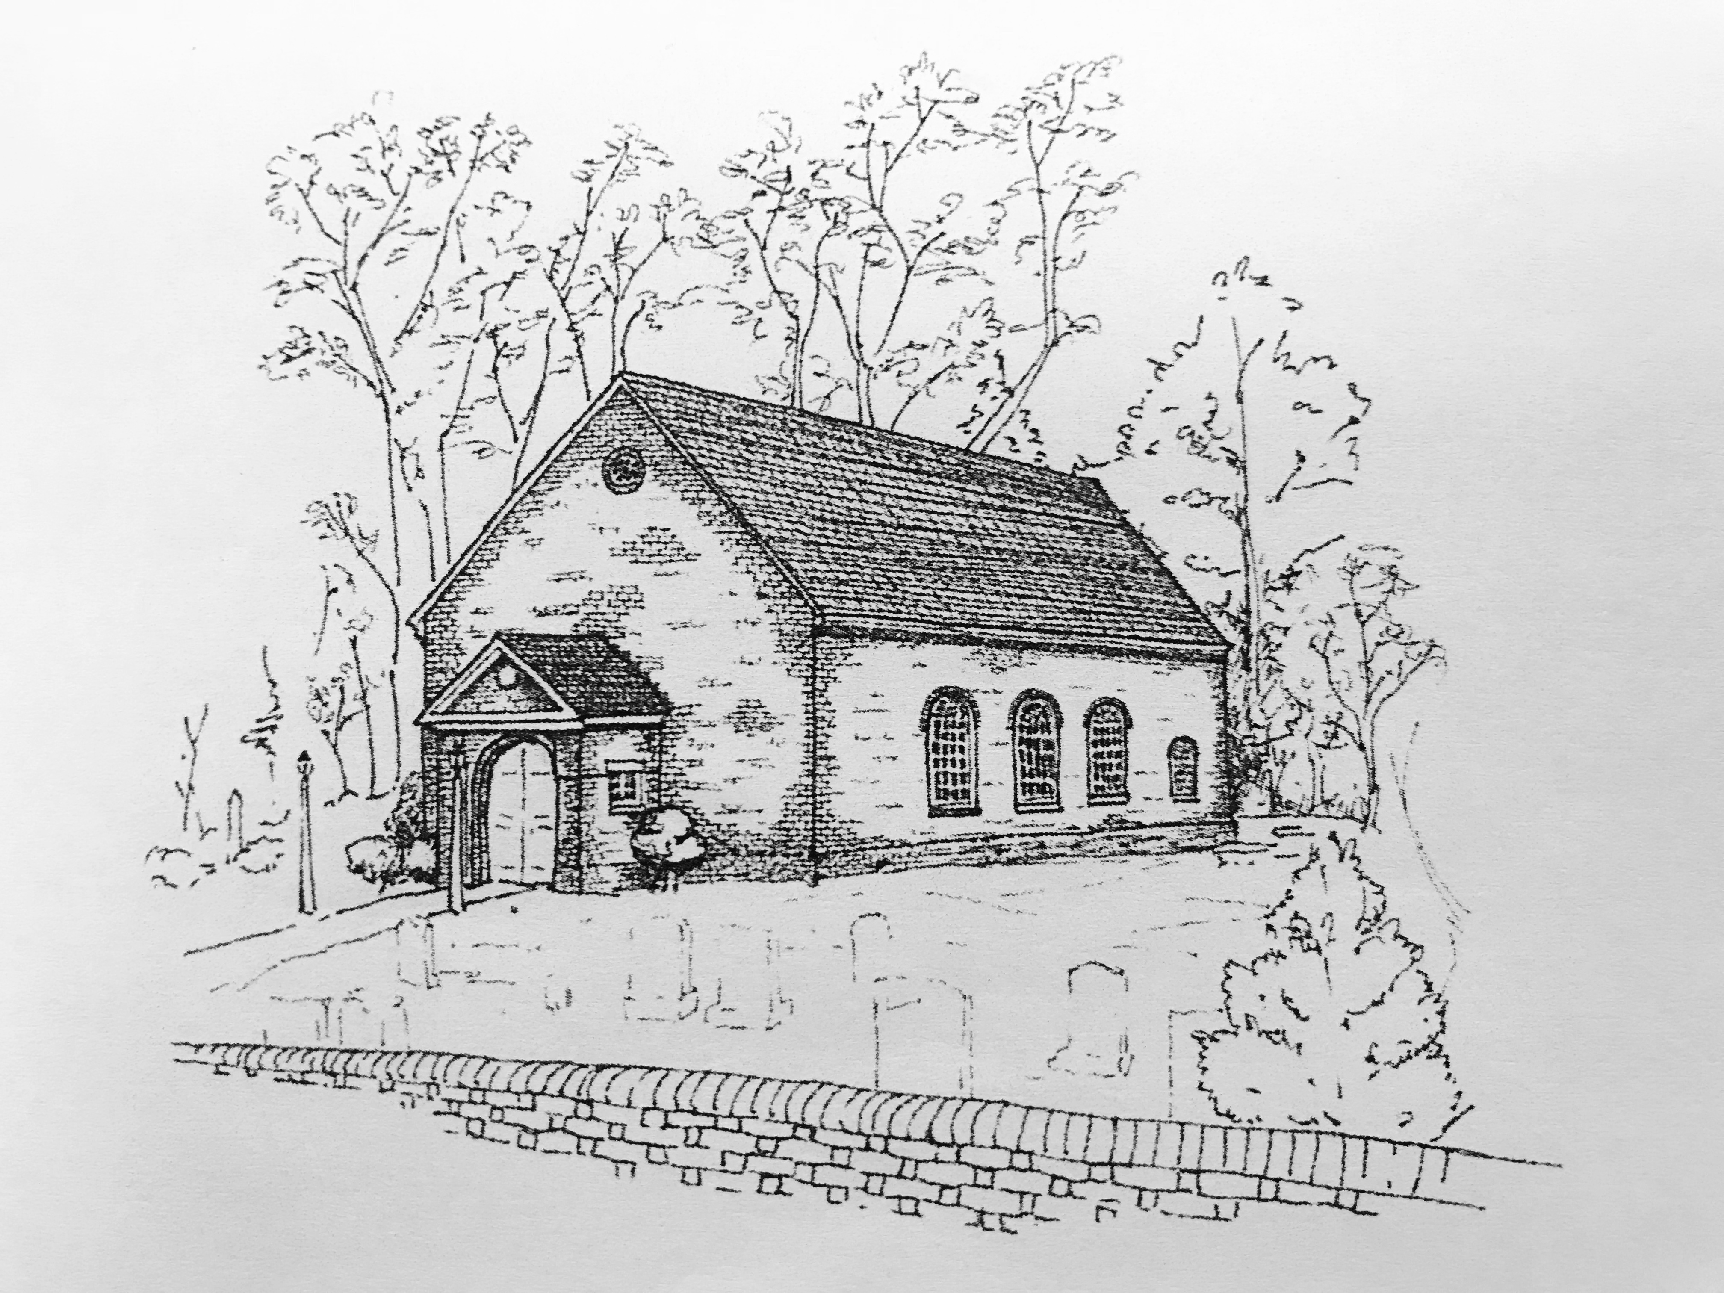
Christ Church Parish (EPISCOPAL) Middlesex
P.O. Box 476, Saluda, VA
(804) 758-2006

